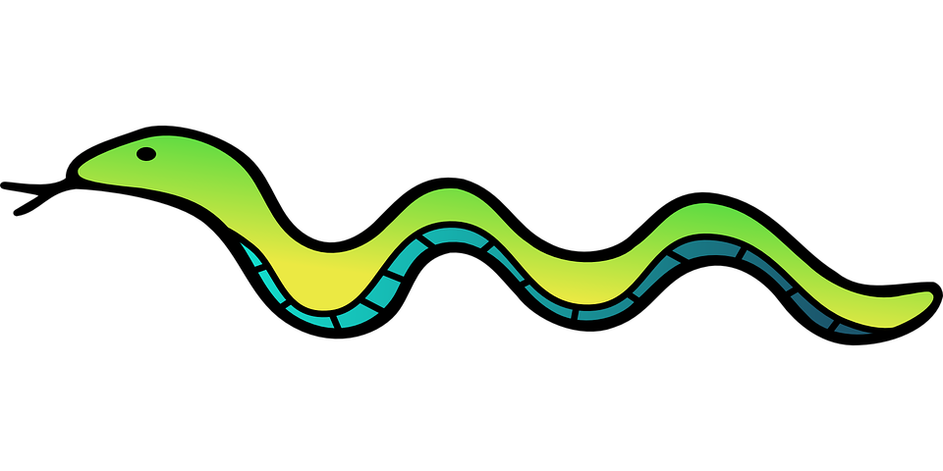

Snake Game Documentation

By

Anil Yogi

1. **Introduction:**

This document details about the design of a snake game. This is a simple single player game that tests the reflexes of the player. This game is all about getting the high score. The game continues unless the snake strikes with any of the obstacles including its own body. Once the snake strikes with the obstacles, the game gets over and score is displayed.

This game works in web browser and is made using JavaScript, HTML and CSS.

1. **Design Overview:**

**Project requirements:**

1. This game will have the screen or board of size 400 pixel in width and 500 pixel in height.
2. The snake will have the length of 20 pixel and width of 20 pixel. The snake will be made with the 1 box of size 20 by 20 pixels at initial state.
3. The food will have the size of 15 by 15 pixels.
4. The game will have simple high score and score display.
5. The game will have a game over div.

**System Design:**

At first the game needs to be started by pressing the arrow key (up, down, left, right) and the snake is placed at a place and food is placed at another. As the player press the key snake starts to move. If the snake strikes with any wall of the game board or its own body then the game ends.

If it does not strike with any of obstacles or wall or with its own body, the game continues. Then the system checks if the snake has eaten the food. If the snake does eat the food, the length of the snake increases along with the score. And if the snake does not eat food, then the snake keeps moving as per players command.

**Data Flow Diagram:**

Yes

No

Yes

Yes

No

No

Game Over

Did Snake eat food?

Touch Wall, Body or obstacle?

Initial State of Snake

Play Again?

Increase the length of snake, generate food at random place and increase the score.

Move Snake

1. **Features of Game:**
2. Player can play the game using only up arrow, down arrow, right arrow and left arrow key.
3. Speed of the snake increases as score increases.
4. Food is generated at random placed once it is touched by the snake.
5. Game gets over once snake touches wall of game board or its own body.
6. High score is displayed all the time.
7. Score increases by 1 once snake eats the food.
8. **Functionality:**
9. **Game Board:**

* The size of the game board will be 400 pixels by 500 pixels.
* Snake will move inside the game board.
* Food will be generated inside the game board.
* Score and high score will be displayed just above the game board.
* Game board has green background.

1. **Snake :**

* The snake will have the length of 20 pixels and will be made of 1 box.
* The width of snake will be 20 pixel.
* The length of snake increases as it eats the food.
* Snake will die once it touches wall or its own body.
* Snake will move as per player’s command.
* Snake cannot move to its opposite direction even if the player commands.

1. **Food:**

* The size of the food will be 15 pixel by 15 pixel.
* Once food is touched by the snake, it will be generated at random places.
* Food is not generated outside the game board.
* Food has red color and is round in shape.

1. **Score:**

* It will be displayed just above the game board at the right top corner.
* It will display the current score of the player.
* It will increase once snake will eat the food.

1. **High-Score:**

* It will be displayed just above the game board at the left top corner.
* It will display the high score of a player.
* The high-score will be changed once the player get more score than previous high-score.